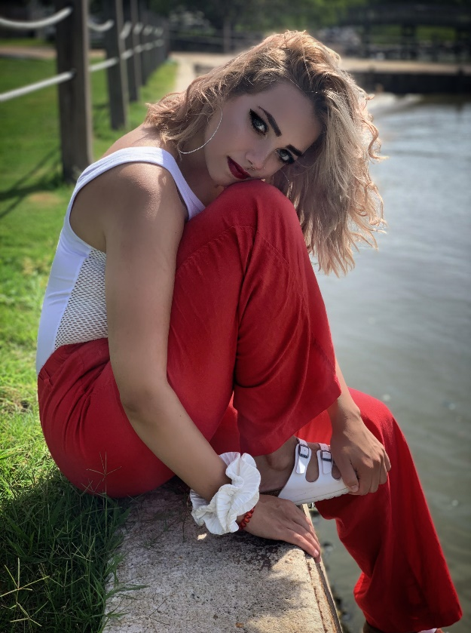

For those who don’t know me I am currently a Junior and an ***English Major*** with a ***double minor in Writing and Spanish at Christopher Newport University*** <https://cnu.edu/>. I grew up in Northern Virginia, specifically in ***Loudoun County***, with one younger brother who is a Freshmen at Christopher Newport University as well.

My first semester of college, I attended ***Longwood University*** in Farmville, Virginia as a student of their exclusive nursing program <http://www.longwood.edu/nursing/>. Having a change of heart and no idea what I wanted to do anymore, I decided to move back home and attend the local community college in NOVA in order to still maintain credits with the ability to live at home and decide on a new future that was better suited to my interests. After touring Christopher Newport in May of 2019, I absolutely fell in love with the campus and decided this would be my new home. Having gone to three different colleges in one year, I had a rocky start to my college career; however, I have found my home at Christopher Newport University and plan to graduate with a bachelor’s degree in English in the spring of 2022.

My first semester here at CNU, I played Trumpet as part of the ***Marching Captains***. <https://cnu.edu/academics/departments/music/ensembles/marchingband/> After being involved in Marching Band, Pep Band, and Pit Orchestra for four years in high school, I wanted to try my hand in collegiate marching band. As a junior, I am on in the ***Varsity Sailing Team*** <https://www.cnusports.com/sports/sailing/roster> and the ***Club Swim Team*** here at Christopher Newport University.

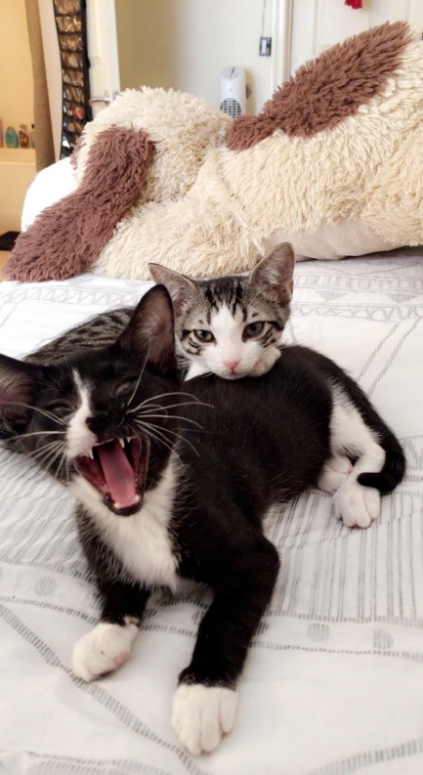 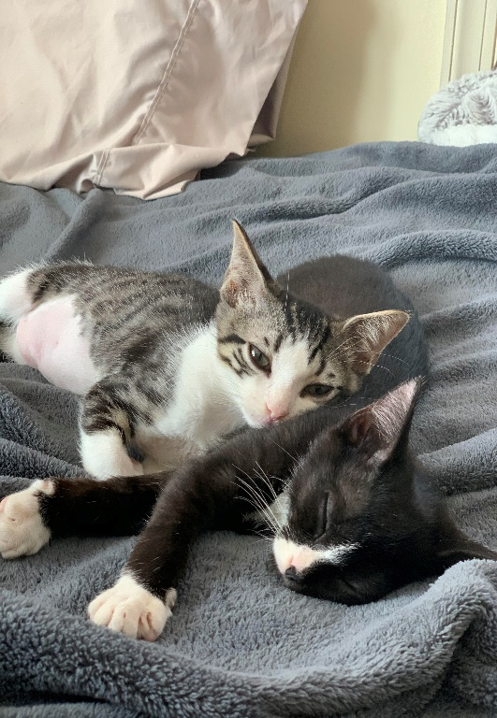

Off campus, I have three cats; one who lives with me here in Newport News and the other two, who reside with my parents in Northern Virginia. I am currently enrolled in my first class of Digital Humanities. Having had no previous exposure to this field, I hope to learn how we can use computers, social media, and various types of research to better our understanding of this field and how it relates to our daily lives. Overall, I hope to become a more concise writer using key focal points within my writing, as opposed to rambling on about a topic.

Although I am taking three writing and reading intensive English courses this semester, which is overwhelming, I have never been more interested in my classwork as it relates to what I will be doing for the rest of my life. Taking my first Digital Humanities course, I had never understood the importance of scholarly work and social media in the professional setting. I am currently seeking more in-depth knowledge in Digital Humanities, as I have had no previous exposure to the field. I plan to pursue a career as a magazine editor and have my own fictional novel series sometime in the future.

Finally, I plan to graduate in the spring of 2022 and move back to Northern Virginia in order to pursue my career as an author and a magazine editor.